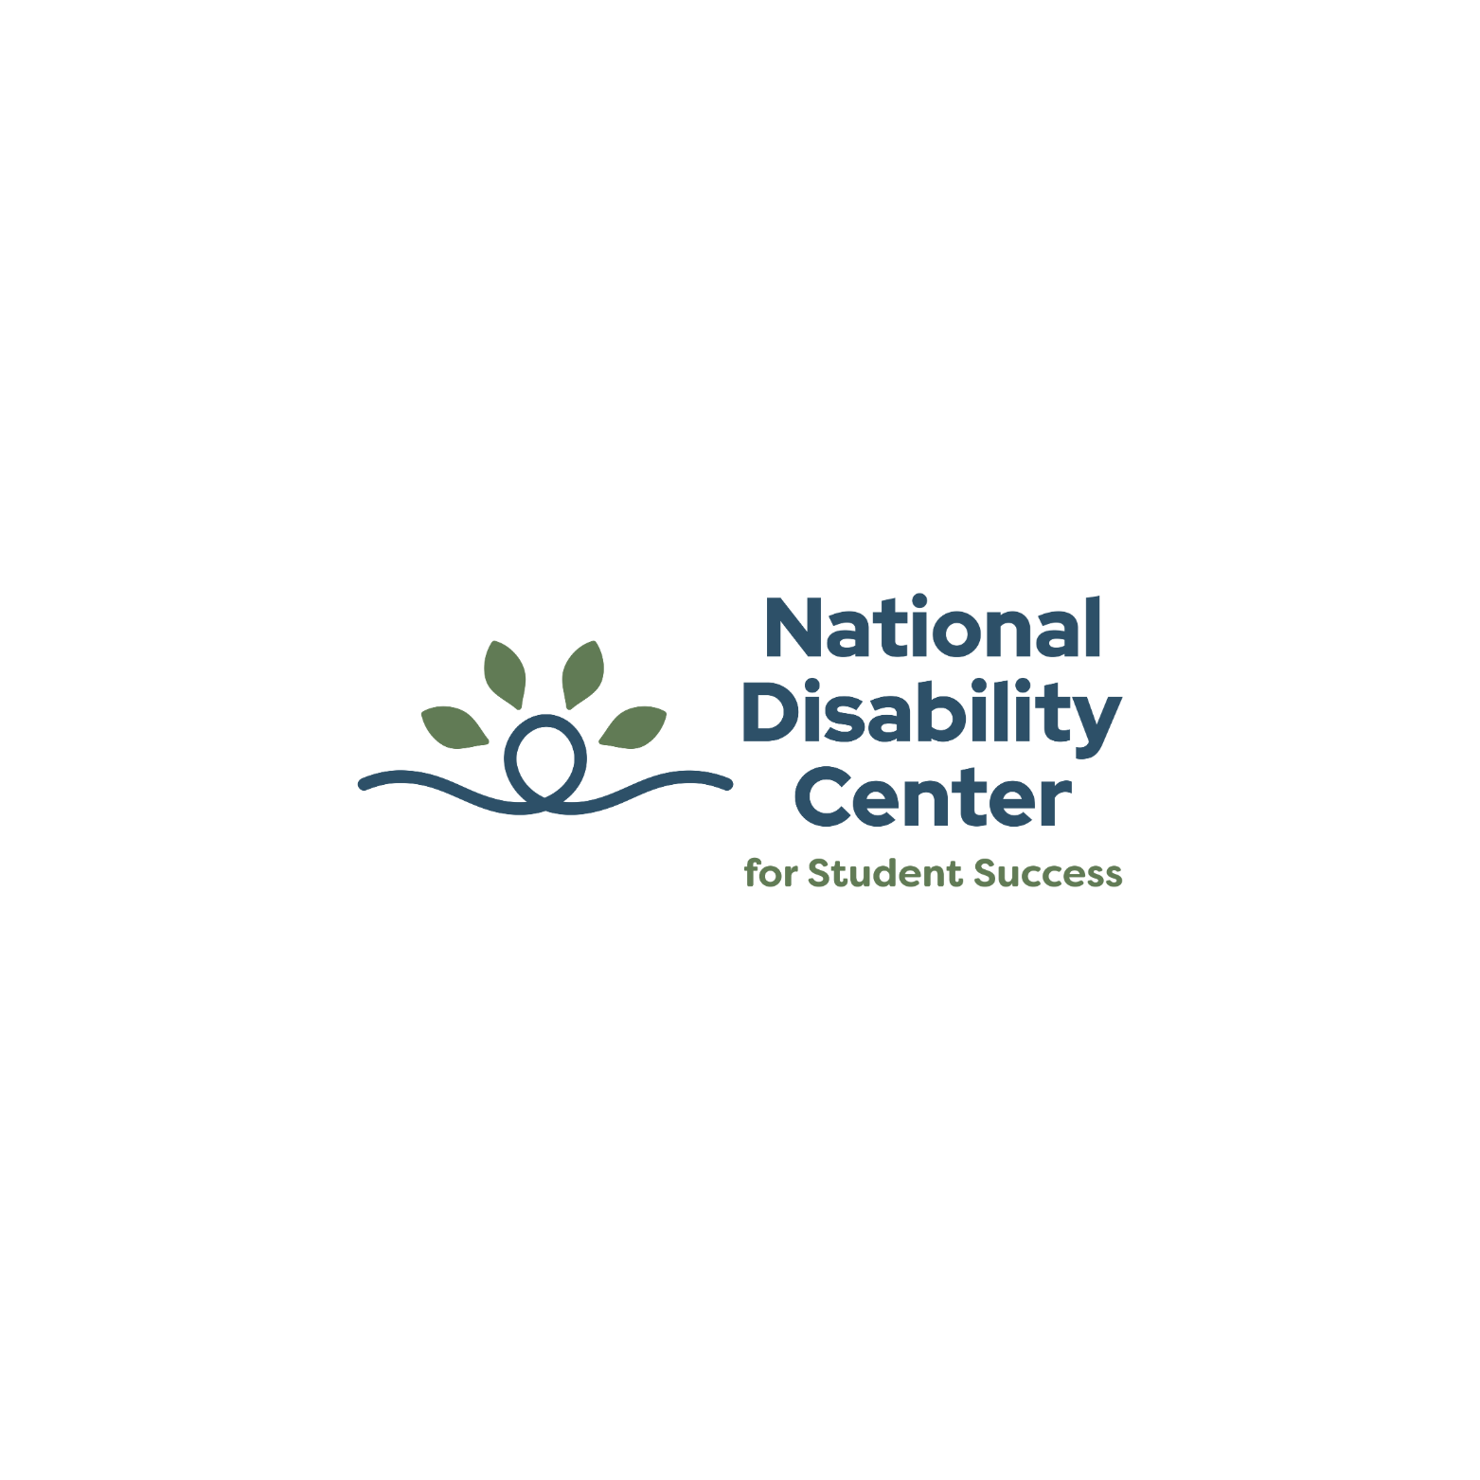

**Transcript: Townhall | September 18, 2025**

[Accompanying Townhall Powerpoint Presentation](https://nationaldisabilitycenter.org/wp-content/uploads/2025/09/September-2025-Townhall.pptx)

**0:00 - Introduction and Background Music (BGM)**

Fall Townhall 2025 | The Next Chapter in Accessibility:Connecting Faculty Practices with  
Student Realities. Hosted by Stephanie W. Cawthon, PhD Executive Director

**0:05 –** **Note and BGM**

For additional details on the Faculty Accessibility Measure findings and Year Two review covered in this Townhall, please download the PPT in the description.

**0:14 – Panel Introduction**  
  
**Stephanie W. Cawthon, PhD:** Hello, welcome to both of you! We're so thrilled that you're both here, our favorite people!

Ryan is currently with the University of Minnesota, working with the programs related to accessibility, a Program Manager for the medical school and researcher from our program last year, we're really thrilled to have you again.

**Ryan A. Mata, PhD:** Thank you.

**Stephanie W. Cawthon, PhD:** Thank you and Maura Borrego, Dr. Maura Borrego is faculty and Professor in the Cockrell School of Engineering and Director our Center of Engineering. Thank you both for joining us today.

We do have some questions to have you prepared for today. I wanted to see if there were any questions or anything that we needed to follow up on from the chats as well.

Are we good to move forward? Okay. Now we can see everyone.

**0:40 – Question 1: CAM vs FAM**  
  
**Stephanie W. Cawthon, PhD:** Ryan, a question I have for you is you were deeply involved in the CAM study with students. You dive deep into the research there. I would like to see how it compared with the FAM, the faculty assessment. And if you can tell us what the difference between those experiences are from your perspective?

**Ryan A. Mata, PhD:** Yeah. Well, thanks again for having me on this panel and I'm really, really excited to have the FAM now come out just a year after we were doing the CAM analysis. So, like you mentioned, a lot of the things that I've been thinking about looking at the FAM data have been some of the patterns that we saw when we looked at data from the students and we have both the quantitative survey data, and then we also have those student interviews that we did. So, we have qualitative data as well. One of the things that really stands out to me is thinking about how we know that Universal Design and accessible strategies in the classroom can benefit all students, not just disabled students.

However, we also now know that proactive accessibility strategies or on the flip side, barriers to accessibility can impact the faculty experience and not just the student experience.

So, faculty are now implicated in this discussion about making a more accessible learning environment, not only as the people who make that environment for students to thrive in, but we're now seeing that they have their own barriers that they face and also unique benefits from accessibility considerations for faculty members.

**Stephanie W. Cawthon, PhD:** I agree.

Maura, you also were deeply involved in thinking about the faculty and what their perspective on disability is and accessibility and why they make decisions about providing accommodations or how to meet students where they are. And, you know, how did you originally respond to the results that you saw from the survey?

**Maura Borrego, PhD:** There's one thing that's starting to emerge that I want to emphasize I'm very excited about. So, we're not the first people to survey faculty about their willingness to accommodate students and the supports that they're receiving, but a kind of a new result that's starting to emerge is this idea that you are a better instructor if you have experience living with a disability and maybe even as a student having to have asked for help or navigate difficult systems.

So, I know that the way that our item is worded is about having more confidence, creating accessible learning environments for students, but I am, I'm excited. It's not really an unexpected result, but I am excited that we're starting to see some research evidence that that this is the case.

**Stephanie W. Cawthon, PhD:** I think a lot of our discussion has been about how to reframe confidence. Or when you're self or is it self-reporting? So, if I'm self-reporting what I'm doing, I say that I'm providing all the accommodations that one might need. So, do people feel like that's the case? You know, and our students here are telling us that it's not happening. So, is it the case that they're doing it because they're, or saying they're doing it because they're self-reporting? So, this is why we changed it to how confident they feel, and this is to change it into more of a psychological perspective around it and also, the institutional support, I feel like, when we're discussing research, and other things, but at the same time, how do we merge that together with the critical pieces? So, I feel like, you know, that's how we care for all of the students and the results.

**5:29 – Question 2: Faculty Support & Institutional Barriers**  
  
**Stephanie W. Cawthon, PhD:** And Ryan, I'm wondering about your current situation. Can you talk a little bit more about your job and what kind of experience that you see resulting with faculty support around disability for students? And, you know, is it formal or informal? Can you talk about that?

**Ryan A. Mata, PhD:** Yes, definitely. So just to give some background information up front, I have started as a Program Manager at the University of Minnesota Medical School. So, I help create and deliver career development programming for students and trainees that are at the medical school.

So, accessibility is a key consideration of programming when it comes to planning and execution of events. Now as a staff member, I realize that we are uniquely positioned to both give resources and facilitate accessibility for faculty and for students.

You might have also noticed that we try as a center to pay attention to faculty perspectives, student perspectives, and staff perspectives. So, I think it's just important to realize that now that we know that faculty have their own issues, making things completely accessible, or even navigating their own space on campus, it just means that it's all the more important for institutions and staff members are agents of those institutions to not only contribute to accessibility initiatives that are student-facing, but also ones that are staff-facing.

Some more concrete examples that I can give you about our current situation. We have an upcoming deadline to make digital content accessible because of Title II of the ADA. So, there were widespread audits of the digital learning environment. So, our external facing websites and then also our internal systems like Canvas, Blackboard, your school might have and we're also a large state university. So, faculty have a lot of demands, that are exceeding their resources. That main resource being time.

They need to engage in research. They need to help mentor their trainees and then attend to their, you know, coursework, grading, all of that administrative stuff. So, that's where I'm seeing staff come in.

**Stephanie W. Cawthon, PhD:** I agree. I love staff and I feel like people don't realize exactly how much we depend on them and how important the staff is and how important it is to recognize their contributions to everything running so smoothly at a university.

So, Maura, what do you think about the factor analysis, the EFA. Can you tell us what your perspective is there?

**Maura Borrego, PhD:** Yeah. So, there's you know, there's two factors like an individual confidence and agency and, you know, what you're doing as an individual instructor and then the other factor was about the institutional support. So, I think those are two really big important components that complement each other and then I think, going forward with this research as you're doing the interviews, what I would want to explore is even having resources for faculty on campus doesn't necessarily mean that they will be able to take advantage because of some of the things that Ryan just said.

You have limited time to do this and so we can make it easier for people, but maybe not necessarily so easy that they will actually take advantage of the opportunity. So, I think the interviews would be able to help us figure out just where are the gaps and what are some of the additional barriers beyond just having the resources available for people to actually

access the resources and put those into practice in their teaching and their other interactions with students.

**Stephanie W. Cawthon, PhD:** Yeah, I think some of the stuff we've gotten from the other research is that silos, individual silos within our research communities as well. The institutional silos, because, you know, the umbrella of DSS office being siloed within these large institutional umbrellas, student development policies, and the policymakers and, the folks who are making content and other things available, and we're all in these individual silos. And how do we collaborate together, with the faculty needs in mind? Keeping that in mind, it's really important to communicate across all of those individual silos and connect the departments between the institutional priorities and the student impacts and make sure that those are linked together in a pipeline, you know, that they're all connected. It's a very long chain, you know, as we know.

**12:44 – Question 3: Supporting New Faculty**  
  
**Stephanie W. Cawthon, PhD:** So, the last question I have for both of you, is how do you support new faculty, brand new faculty that just arrived onto your institution and how do you talk to them today about the practices with accessibility? What do you do? How do you approach it to expand on what their role is as a classroom teacher? Where do we start with that? What do we do?

**Ryan A. Mata, PhD:** I can jump in there.

**Stephanie W. Cawthon, PhD:** Ryan, OK.

**Ryan A. Mata, PhD:** So, supporting new faculty, I think we can draw some parallels to supporting new students, students who are transitioning from other institutions, folks like that, where the existence of the resources is known by the person. They know they're out there somewhere floating in the ether, especially when they're at a large institution, like you mentioned earlier, Stephanie, one that might be heavily siloed.

As you can imagine, where I come from, the medical school tends to have its versions of units, whereas other colleges on campus may or may not have those same units or resources and so, really giving that faculty member an orientation experience that is empowering and that is made by other faculty members and that gives the most kind of vital information to that faculty member moving forward. Of course, I can give a little bit more of a pragmatic flavor to that statement and say that in any orientation for faculty that we would have at Minnesota, they're going to be hearing about the legality of accessibility and making sure that all of their material is compliant.

So, I can also add that would be a very, big part of their learning about accessibility standards and how to kind of view it as a best practice in the design of their courses. So, really just starting from the beginning, I think orientation is a great idea. You know, preach accessibility as a value and have more, you know, senior faculty members be able to mentor the junior ones.

**Maura Borrego, PhD:** Yeah, I would echo.

**Stephanie W. Cawthon, PhD:** I was just going to say before you start, Maura, that we just read, we just developed a faculty meeting guide, like a handbook for us to discuss with the faculty about new accessibility topics and new opportunities for those faculty. And Maura, I'm sorry to interrupt you, please, your reply and we're switching interpreters.

**Maura Borrego, PhD:** Yeah, I want to echo what Ryan said about mentoring as a senior faculty member. I'd like to be available to new folks on our campus and be able to talk to people throughout the year because I know orientation and getting settled in a new place can be really, really overwhelming, teaching a class for the first time, all of those things.

So, to be able to help people get just-in-time information would be really helpful and then also I really like the resources that the center's coming up with. I can't really take credit for having a lot of those and they did not pay me to say this, but I think the team has put a lot of energy into making a nice website that you can access in, you know, from lots of different directions and different ways and different formats and so even just in a few minutes on the site, you can learn something that is useful that you can put into practice and so there is tons of research out there, but, you don't have to be an expert or be able to read research articles in this space, you just need to be able to go on the website with some questions about how do I support the students in my teaching.

**Stephanie W. Cawthon, PhD:** I love that we have the website and hopefully we continue to expand on the teaching experience. And I personally, in the department I'm in, I have, when a new person arrives, I'm able to just clue them in with that website. And it has strategies for teaching, and it puts them accountable and the information's accurate so they can do the one-on-one and not have to have this huge orientation that's overwhelming in large groups.

But I know if you have a new student who's teaching a class and they're considering accessibility, it gives you the top 10 lessons, so to speak. So, you already know what you're expecting with the university, the relationship, the development, the building of confidence, the safe place, so to speak, where you go from now immediately. I've noticed some people are putting things in the chat. Thank you for sharing. I'm hoping that people will go ahead and click on it and see what they're interested in.

Time is running out. I know it goes very fast. I want to thank both you, Maura and Ryan, for sharing your perspective so much. To all the panelists, thank you.

Thank you so much.

**18:32 – End of Panel Discussion**

**18:33 – Learn More and BGM**

To learn more, visit:<https://nationaldisabilitycenter.org/>

**18:38 – Follow Us and BGM**

LinkedIn: <https://www.linkedin.com/company/national-disability-center/>

Facebook: <https://www.facebook.com/people/National-Disability-Center-for-Student-Success/61550829841761/>

Instagram: <https://www.instagram.com/nationaldisabilitycenter/>

Bluesky: <https://bsky.app/profile/natldisability.bsky.social>

**18:43 – Legal Disclaimer and BGM**

© 2025 National Disability Center for Student Success. This research center was developed with grant #R324C230008 from the Institute of Education Sciences (IES). However, its contents do not necessarily represent the policy of the IES or the U.S. Department of Education, and you should not assume endorsement by the federal government.  
Project Officer: Akilah Swinton Nelson, PhD.

**18:48 – End of Townhall**